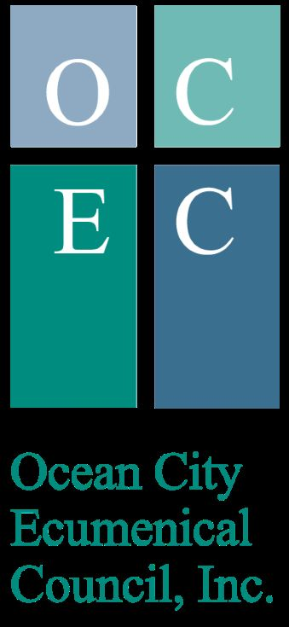
OCEAN CITY ECUMENICAL COUNCIL
VOLUNTEER FORM

Delegate (Church Affiliation)________________________________________
Delegate At Large Recommended by________________________________
Name______________________________________________ (Please Print all information)
Address______________________________________________________________
Phone_______________________________________________________________
Email Address_________________________________________________________
Background___________________________________________________________
_____________________________________________________________________________________________
_____________________________________________________________________________________________
Volunteer History__________________________________________________________
_________________________________________________________________________
_________________________________________________________________________
Your Interest In Serving___________________________________________________
_________________________________________________________________________

_________________________________________________________________________

Mission Statement
The Ecumenical Council of Ocean City is faith based and organized to gather food, clothing and money to feed and clothe those in need, to cooperate and participate with the Ministerium and to encourage joint worship services.

_______________________________ ________________________
Signature Date
Return form: OCEC, PO Box 1001, Ocean City, NJ 08226

(Volunteer Form Delegate & DAL)
1/13/23

